Game NO. | Game Name | Game size | Remark | Picture
0081 | Luxor | 7Mbits | 1008 | 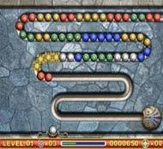
0080 | Sudoku | 6Mbits | 857 | 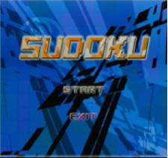
0079 | Wild Gun | 24Mbits | 3183 | 
0078 | Texashold’em | 8Mbits | 1111 | 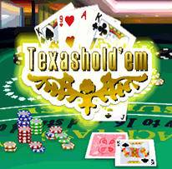
0077 | Side Pocket *開發中 | 8Mbits | 1126 | 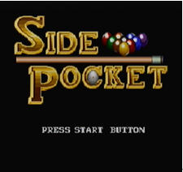
0075 | Cook Off | 6.5Mbits | 945 | 
0074 | Driller Man *開發中 | 7.5Mbits | 1064 | 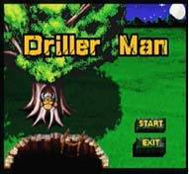
0073 | Hexapod | 16Mbits | 2154 | 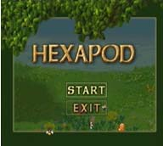
0072 | Open Season | 15.5Mbits | 2092 | 
0071 | Space War | 7.5Mbits | 1044 | 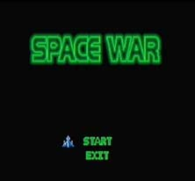
0070 | Happy Halloween | 4Mbits | 640 | 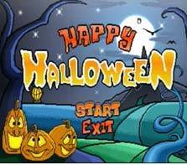
0069 | The King of Pirates | 14Mbits | 1900 | 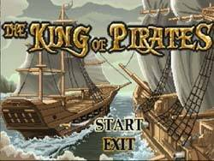
0068 | Snooker | 2Mbits | 382 | 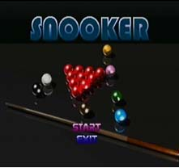
0067 | Hit Toy | 6.5Mbits | 913 | 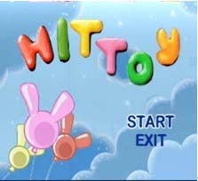
0066 | Snow Battle *開發中 | 14.5Mbits | 1975 | 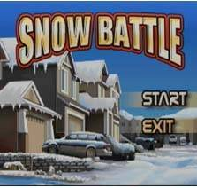
0065 | Road Racing | 8Mbits | 1135 | 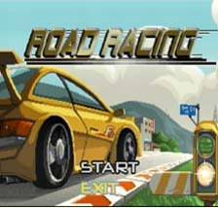
0064 | Pirates | 10Mbits | 1380 | 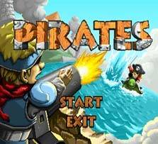
0063 | Adventure | 7Mbits | 1024 | 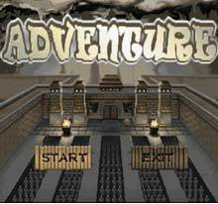
0062 | Domino | 7.5Mbits | 1058 | 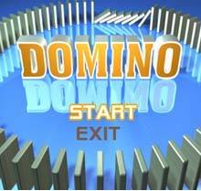
0061 | Brain Test | 12Mbits | 1664 | 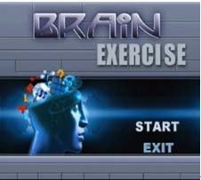
0060 | Hold Fruit | 1.5Mbits | 275 | 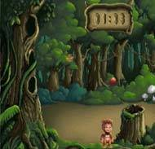
0059 | Cross River | 3Mbits | 504 | 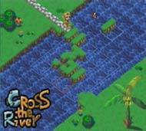
0058 Crazy Rocket 4Mbits 604 | Crazy Rocket | 4Mbits | 604 | 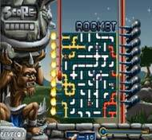
0057 | Tank Patrol | 4.5Mbits | 678 | 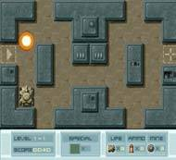
0056 | Penguin | 4.5Mbits | 661 | 
0055 | Shooting King | 7Mbits | 998 | 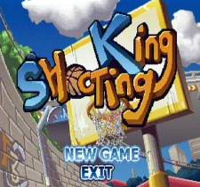
0054 | Lion Roar | 10.5Mbits | 1441 | 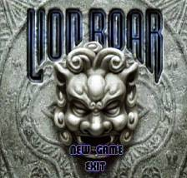
0053 | Goal | 7Mbits | 1010 | 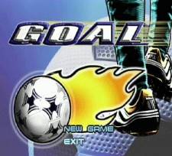
0052 | Bubble Man | 5.5Mbits | 792 | 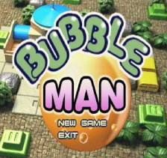
0051 | Battle Front | 8.5Mbits | 1177 | 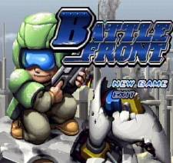
0050 | Top Ball | 1Mbits | 206 | 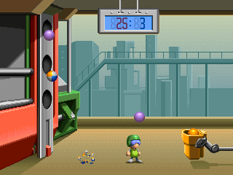
0049 | Shooting Ball | 1Mbits | 239 | 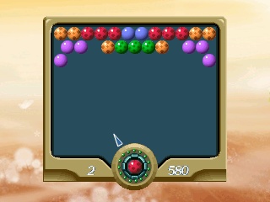
0048 | Hit Brick | 1.5Mbits | 258 | 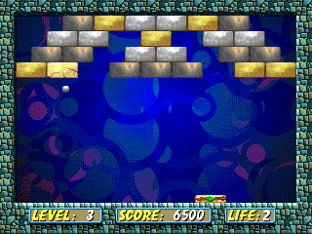
0047 | Golf | 7Mbits | 1005 | 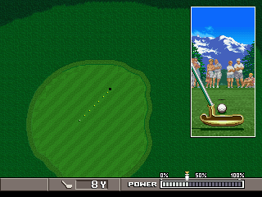
0046 | Spin | 2Mbits | 323 | 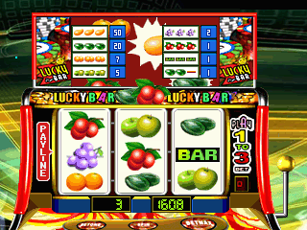
0045 | Poker | 1.5Mbits | 260 | 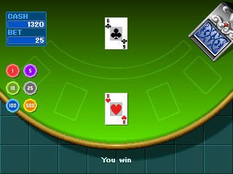
0044 | Black Jack | 1.5Mbits | 278 | 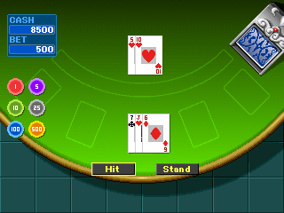
0043 | Span | 1.5Mbits | 258 | 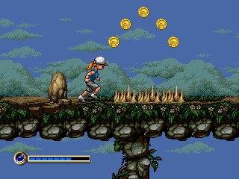
0042 | Motor Boat | 7Mbits | 999 | 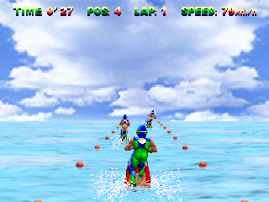
0041 | Maze Car | 2.5Mbits | 422 | 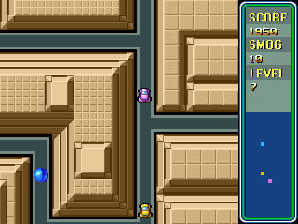
0040 | Cross Country | 7.5Mbits | 1026 | 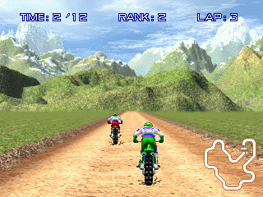
0039 | Beach Racing | 7Mbits | 993 | 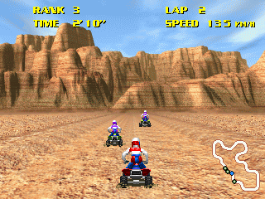
0038 | Snake | 1Mbits | 201 | 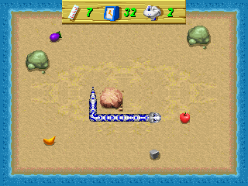
0037 | Sonic X | 1.5Mbits | 311 | 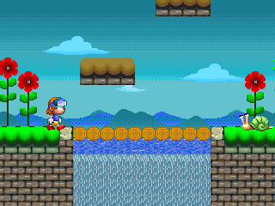
0036 | Triangle Plane | 2Mbits | 355 | 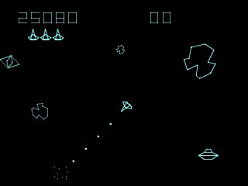
0035 | Tank War | 1Mbits | 244 | 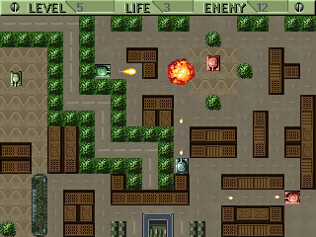
0034 | Tank | 3Mbits | 503 | 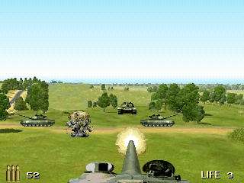
0033 | Shoot Birds | 2Mbits | 325 | 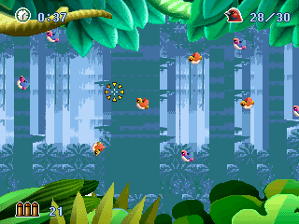
0032 | Parachutist | 2Mbits | 341 | 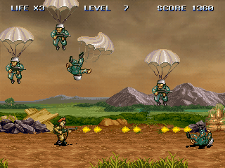
0031 | Moon Tank | 2Mbits | 370 | 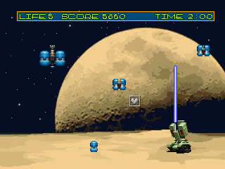
0030 | F14 | 12.5Mbits | 1668 | 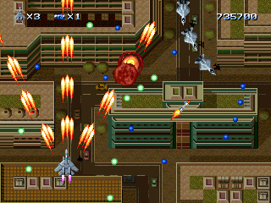
0029 | Bosconian | 1.5Mbits | 267 | 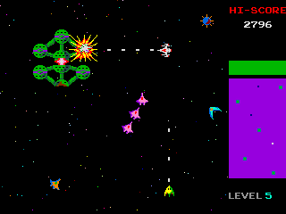
0028 | Apaqi | 11Mbits | 1527 | 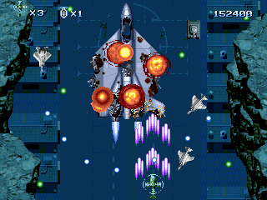
0027 | 1945 | 13Mbits | 1762 | 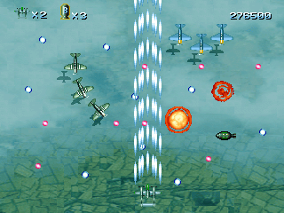
0026 | Treasure Brick | 1Mbits | 241 | 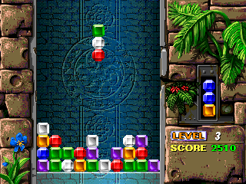
0025 | China Brick | 1Mbits | 242 | 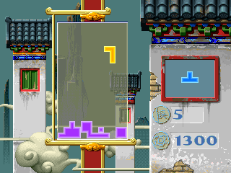
0024 | Math | 2Mbits | 357 | 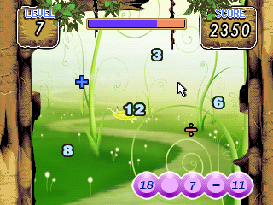
0023 | Elevator | 2Mbits | 362 | 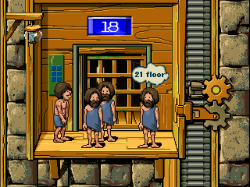
0022 | Bomber | 1Mbits | 231 | 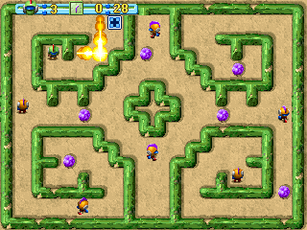
0021 | 3D Bean | 4Mbits | 592 | 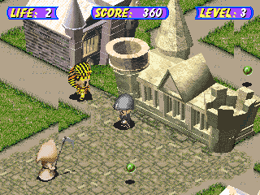
0020 | Brick Break | 1Mbits | 224 | 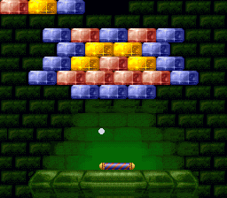
0019 | Block Bat | 1Mbits | 248 | 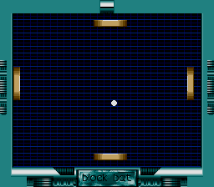
0018 | Ball Pad | 0.5Mbits | 187 | 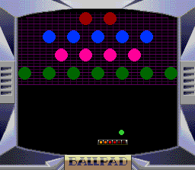
0017 | Box Man | 1Mbits | 203 | 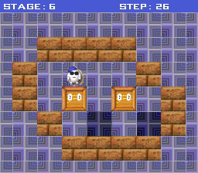
0016 | Labyrinth | 1Mbits | 256 | 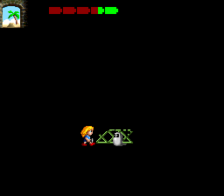
0015 | Virus Killer | 1Mbits | 204 | 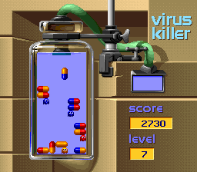
0014 | Puzzle Attack | 1Mbits | 208 | 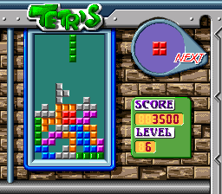
0013 | Sub War | 1Mbits | 240 | 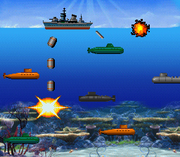
0012 | Street War | 1Mbits | 231 | 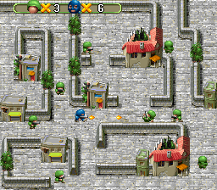
0011 | Penalty Cup | 2Mbits | 368 | 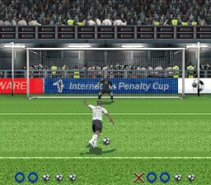
0010 | Mosaic | 1Mbits | 219 | 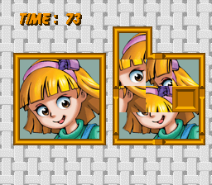
0009 | Motor Racing | 2Mbits | 338 | 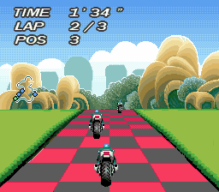
0008 | Linking | 1Mbits | 202 | 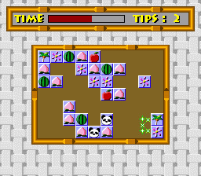
0007 | Cute Puzzle | 0.5Mbits | 189 | 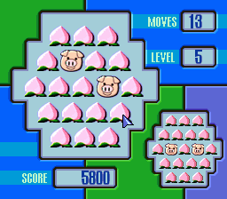
0006 | Save General | 1Mbits | 207 | 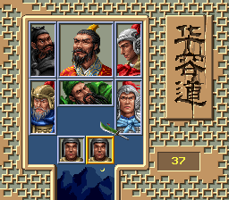
0005 | Glyptics | 1Mbits | 215 | 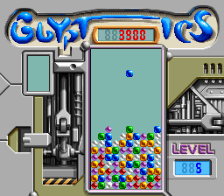
0004 | Search Twins | 0.5Mbits | 188 | 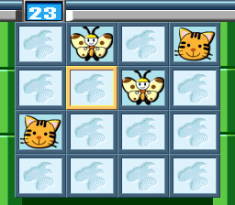
0003 | BombMan | 1Mbits | 200 | 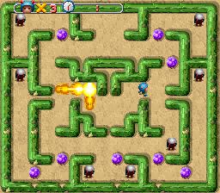
0002 | Star War | 1Mbits | 231 | 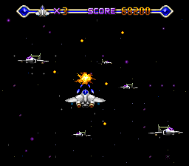
0001 | Air Force | 1Mbits | 206 | 

